ANNA LOU WELLNESS
Beautifully Whole
Homepage Final Consolidation — Annotated
All feedback across all versions, with visual references.
For: Sameer, Xceed Imagination
From: Anna Lou
Date: 21 April 2026
Subject: Final direction and complete fix list across every round. Build forward from this document only. Images are pulled from your own mockups so you can see exactly what I am referring to.

Summary
You have sent three homepage versions that I have given feedback on. This document consolidates every round of feedback into one final direction and one complete fix list, with the relevant screens embedded against each fix so there is no confusion about what I am referring to.
Do not build any single version in isolation. Build the combined direction set out in Section 1 below, which takes the strongest element from each version and reinstates everything from the original brief that has gone missing along the way.

1. The final direction
Take all of the following forward together. This is the build-from direction.

Navigation — colour-coded, as in the First Final Version
Each main nav section carries its own brand colour permanently. This was in the First Final Version and was dropped in the Magazine series. Reinstate it. See the full colour map in Section 3.
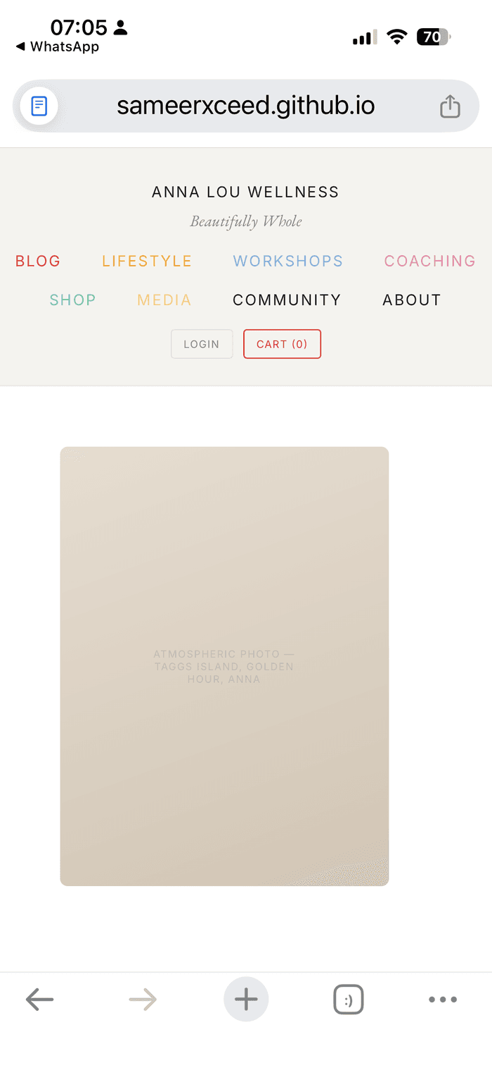
KEEP First Final Version — correct colour-coded nav system. Keep.

Editorial framing — Magazine model
Issue No. 01, Spring 2026. Inside this issue. Garamond typography throughout for headings, body, and accents. Drop caps in red on featured stories. This is the right editorial mood and should anchor the whole site.
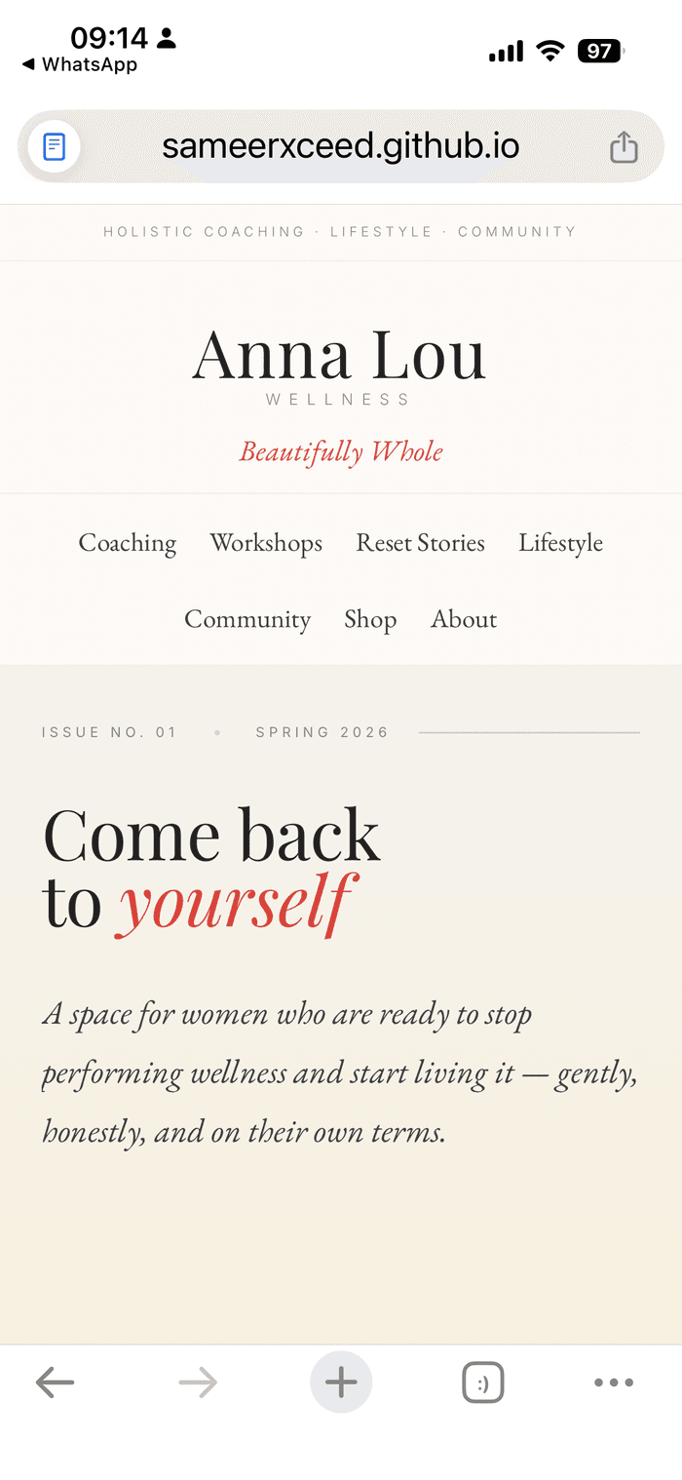
KEEP Magazine V2 — keep the Issue No. 01 framing, Garamond typography, red italic 'yourself'.

Palette — warm cream base from V1
Use Magazine V1 as the base. Warm cream and tan neutrals throughout, less pink-heavy than V2. Vary the sections with the accent colours from the brand palette so nothing reads as a continuous band of one tone.
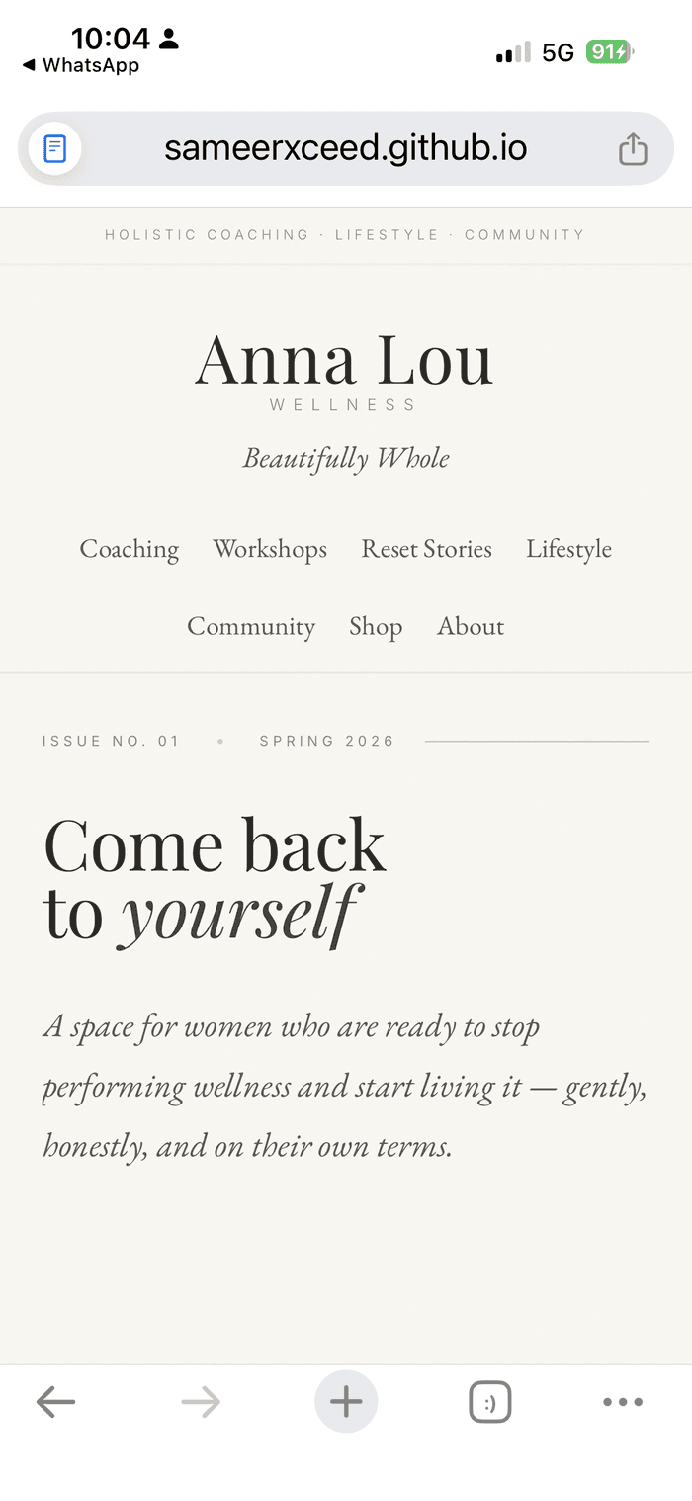
KEEP Magazine V1 — warm cream palette. Use as the base.

Red editorial punch — keep V2 quote slide
Bring back the full-bleed red quote slide from Magazine V2. This was the single most striking editorial moment in any version. It should not be lost. Apply it throughout for key quotes, not only once.
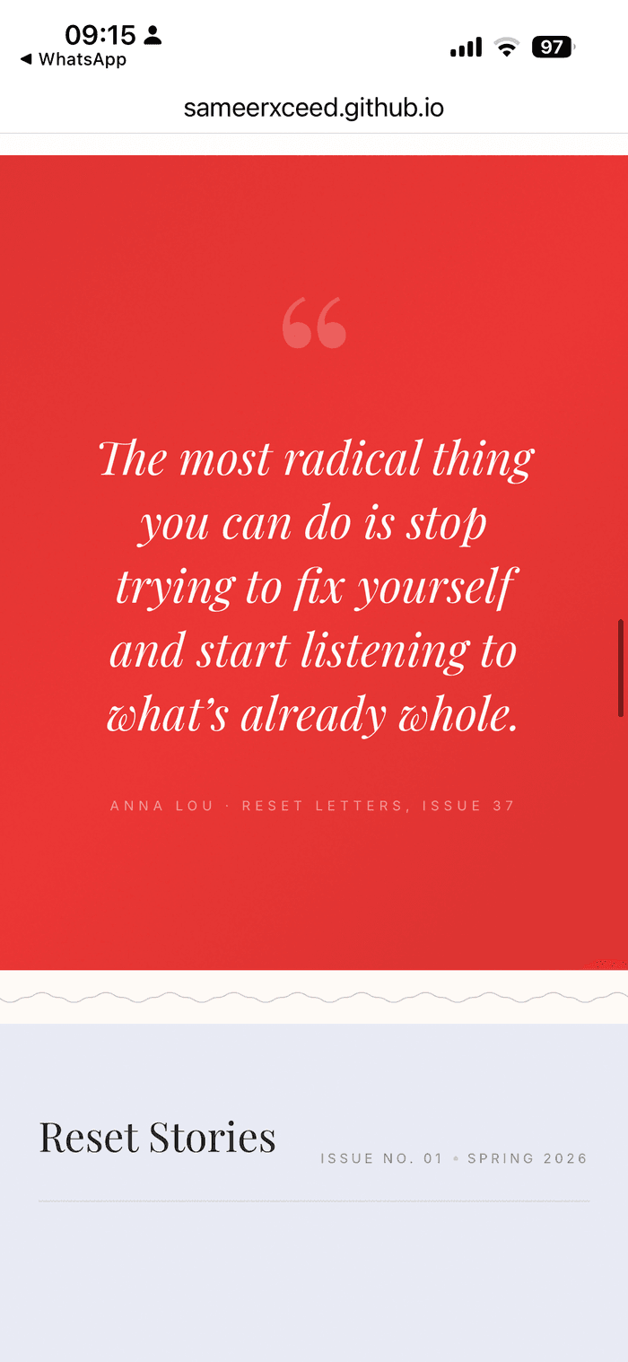
KEEP Magazine V2 — full-bleed red quote slide. Use throughout for key quotes.

Logo — one horizontal line
Typed wordmark on one horizontal line reading ANNA LOU WELLNESS. No crown. No stacking. No rotated tagline. Beautifully Whole in Garamond italic centred below the wordmark. The Magazine versions have stacked the logo, which is wrong. Replace with the treatment from the First Final Version.
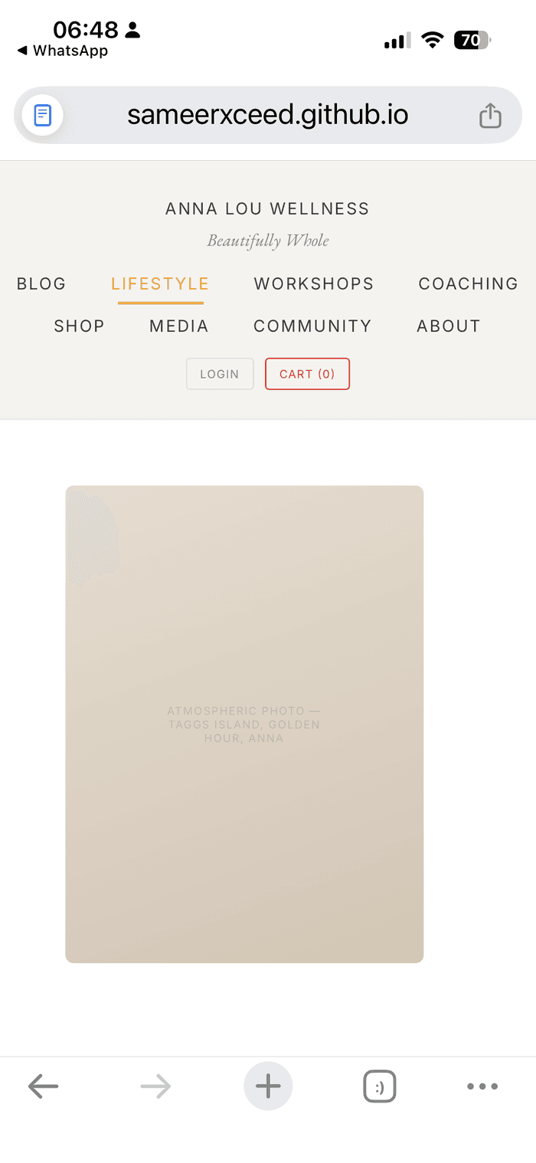  KEEP First Final Version — horizontal wordmark on one line. Correct. |   FIX Magazine V2 — stacked 'Anna Lou / WELLNESS'. Wrong.

Hero CTAs — reinstate
Two clear links at the bottom of the hero: Read the Reset Stories, and Work with Anna. These were in Magazine V2 and got dropped in V1. Reinstate them in the combined build.

Social links
Footer strip at minimum: Instagram, LinkedIn, Substack, YouTube, Podcast. Optionally a smaller social strip in the header area. URLs to follow separately.

Substack integration
Replace any generic subscribe form with proper Substack integration. Either embed the actual Substack subscribe form directly, or replace the form with a Join on Substack CTA that links out to the Substack page. The current generic email field does not connect to Substack, does not add people to the Substack subscriber base, and breaks the two-tier structure.

2. Copy source
All body copy on every page must come from the Volume 3 handoff document: ALW_BLOG_Vol3_COMPLETE_FINAL_Sameer.docx.
No paraphrasing. No placeholder copy. No invented articles. No fictional clients. No inferred text. If the copy is not in Volume 3, ask before writing anything. This applies to article titles, featured story bodies, coaching block copy, workshop descriptions, and the Reset Letters section wording.

3. Colour system (complete)
Every button, label, section background tint, date marker, and accent inside a section must match that section's nav colour. No exceptions.
Section | Primary colour | Hex | Apply to
Blog | Red | #EE312F | Labels, dates, drop caps, category tags, section tint
Lifestyle | Gold | #FAA21B | Labels, buttons, section background
Workshops | Blue | #7BAFDD | Pricing boxes, BOOK buttons, Browse All Workshops link
Coaching | Pink | #F280AA | WORK WITH ANNA button, pricing, labels
Shop | Green | #5DCAA5 | SHOP buttons, product accents, Browse All Jewellery
Media | Light gold | #FFD07A | WATCH / LISTEN / READ labels, YOUTUBE, PODCAST tags
Community | Warm cream | #F5F3EF | Section background, with black text

Specific colour leaks to fix
- Lifestyle. Lifestyle is on mint green in places. Mint green is Shop's colour. Move Lifestyle to gold or cream #FFF0D2.
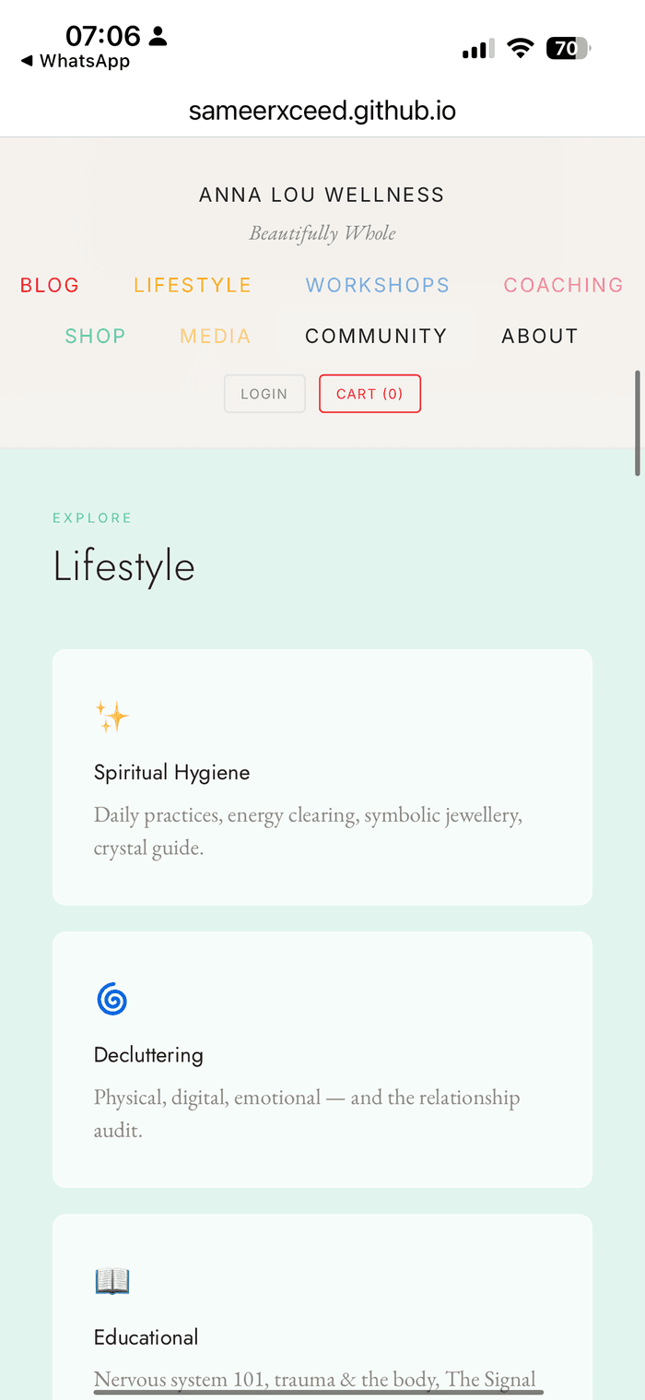
FIX First Final Version — Lifestyle section currently sitting on mint green. Wrong. Move to gold.
- Media. Media labels WATCH, LISTEN, READ, YOUTUBE, PODCAST are in pink in places. Switch to light gold.
- Workshops. Pricing boxes, BOOK buttons, and Browse All Workshops link are orange or gold in places. Switch to blue.
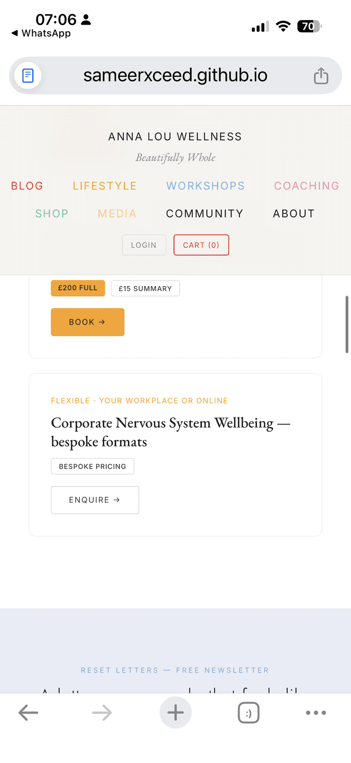
FIX First Final Version — Corporate card BOOK button in orange. Workshops colour is blue. Change.
- Coaching. WORK WITH ANNA button is currently blue. Switch to pink.
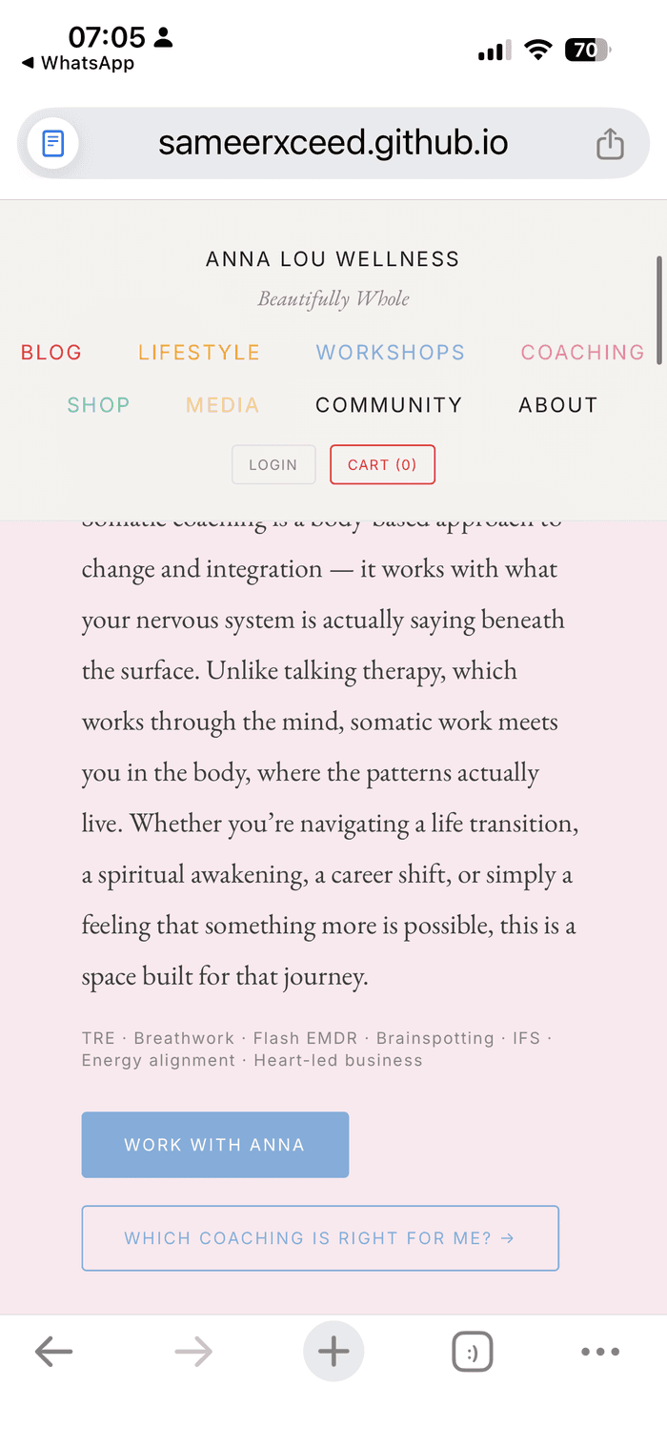
FIX First Final Version — WORK WITH ANNA button in blue. Coaching colour is pink. Change.
- Community. Lavender Returning Circle button. Lavender is not in the brand palette. Change to Community warm cream with dark text.

4. Critical fixes
These have been flagged across multiple rounds. Every item below is open and needs closing out before the next sign-off. Images embedded against each fix show exactly where the problem is.

Programme names on the Coaching section
Currently shows The Full Reset, Trauma-Informed Sessions, The Returning Circle, Single Sessions. None of these match the agreed naming. Rebuild the Coaching section using only these names, which sit underneath The Signal Method as the overarching method:
- The Nervous System Decoder, free
- Workshops, 15 pound summary, 200 pound full
- The Reset, 6 week 1:1
- Signal, and Signal & Build, 12 week 1:1
- One Day, intensive, enquire
- The Signal Collective, mastermind, enquire
- The Reset Room, monthly membership
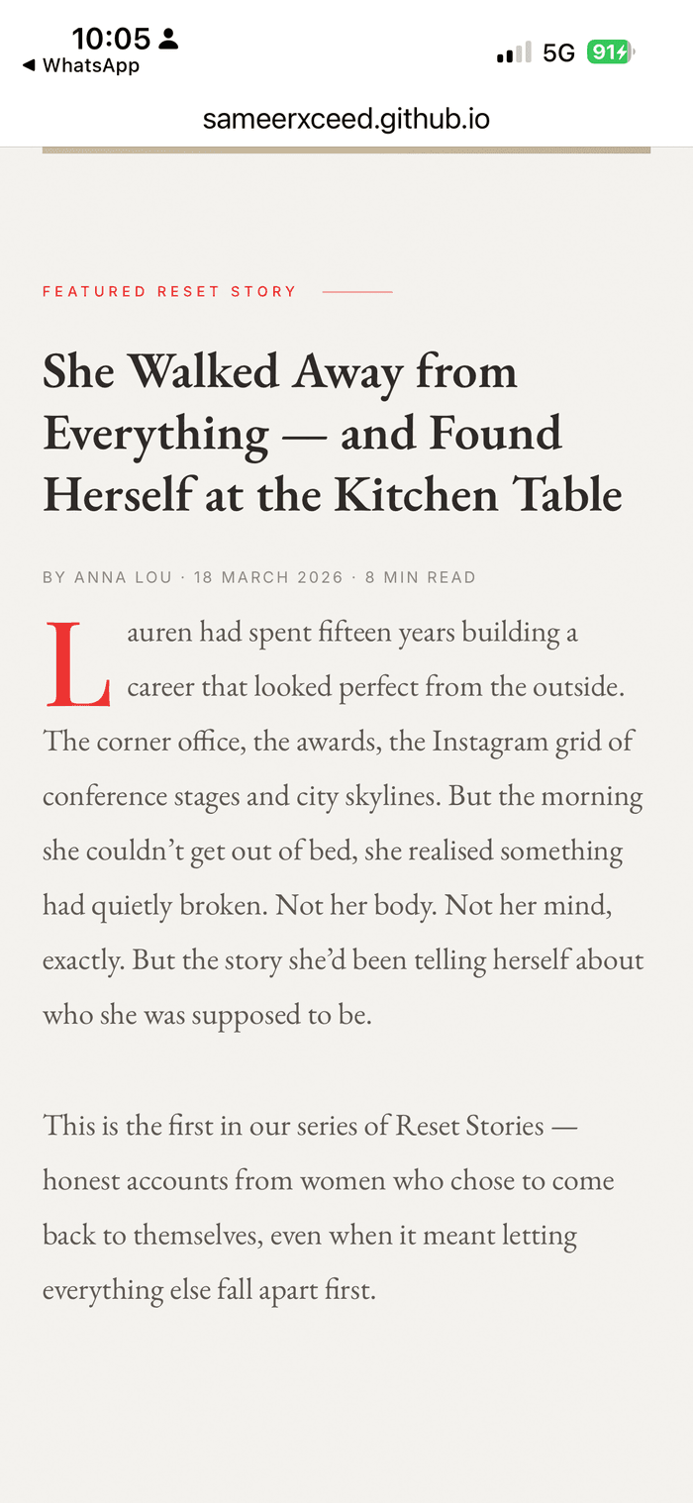
FIX Magazine V1 — wrong programme names currently in the Coaching section. Rebuild with the names above.

The Signal Method
The Signal Method™ is the umbrella method and overarching brand concept. The named programmes above sit underneath it as the saleable products. Keep The Signal Method™ in coaching copy, on the Autumn Reset Day workshop card, and as a searchable term in SEO metadata and AEO targets. Treat Signal Method as the method, and the named programmes as the routes into it.
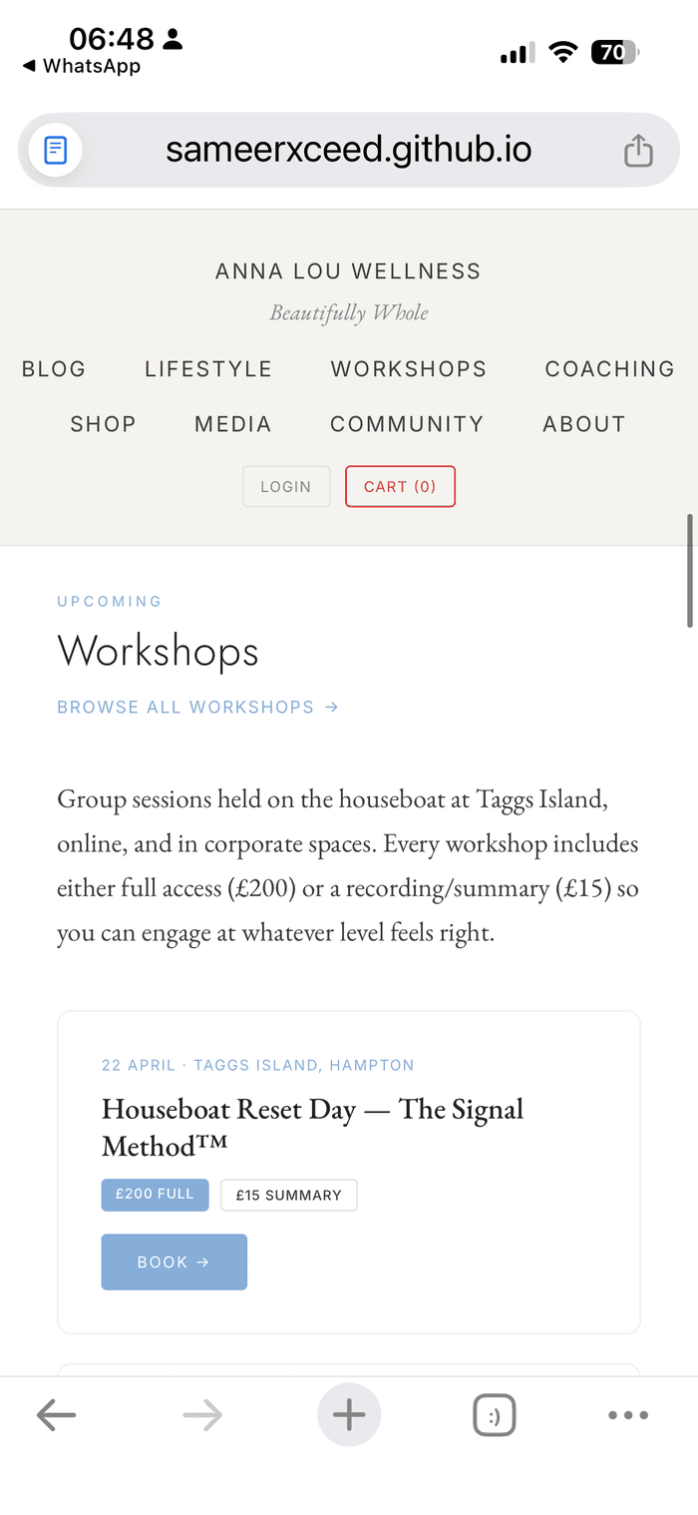
ADJUST First Final Version — Houseboat Reset Day with Signal Method. Signal Method stays. Change title to Autumn Reset Day (see workshop venue fix). Remove the em dash, put Signal Method on a separate line as a subtitle.

Trauma-Informed Sessions — remove as a product
The trauma-informed approach is part of the methodology and belongs on the About page only. It is not a stand-alone programme. Remove from the programme list entirely.

The Returning Circle — move to Community
It is a Community offering, not a coaching programme. Move it out of the Coaching section into Community. It is not women-only. All copy describing it as a women's circle must be rewritten as a circle, a weekly gathering, or similar inclusive language. Venue is The Hare and the Moon, Twickenham.
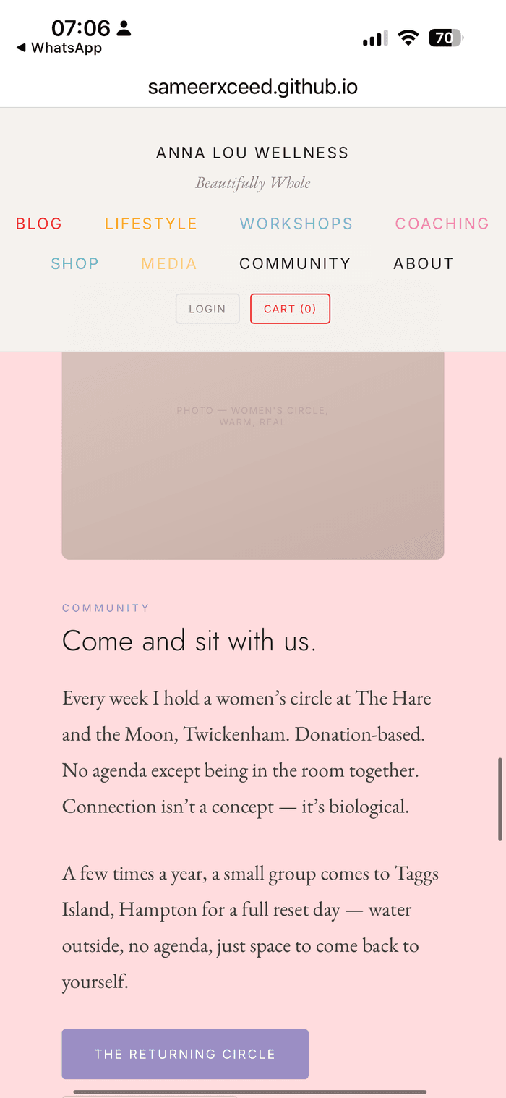
FIX First Final Version — 'Every week I hold a women's circle at The Hare and the Moon'. Change 'women's circle' to 'a circle' or 'a weekly gathering'. Venue stays Hare and the Moon, Twickenham.

Workshop venue and seasonal framing
Workshop venue is Taggs Island, Hampton throughout the site. Every reference to Hackney on the Spring Reset Workshop card is wrong and needs replacing. Also, since the new site launches into the September retreat promotion cycle, rename Spring Reset to Autumn Reset on the workshop card. The two distinct locations on the site are therefore: The Hare and the Moon, Twickenham, for the weekly Returning Circle; and Taggs Island, Hampton, for retreats and workshops.
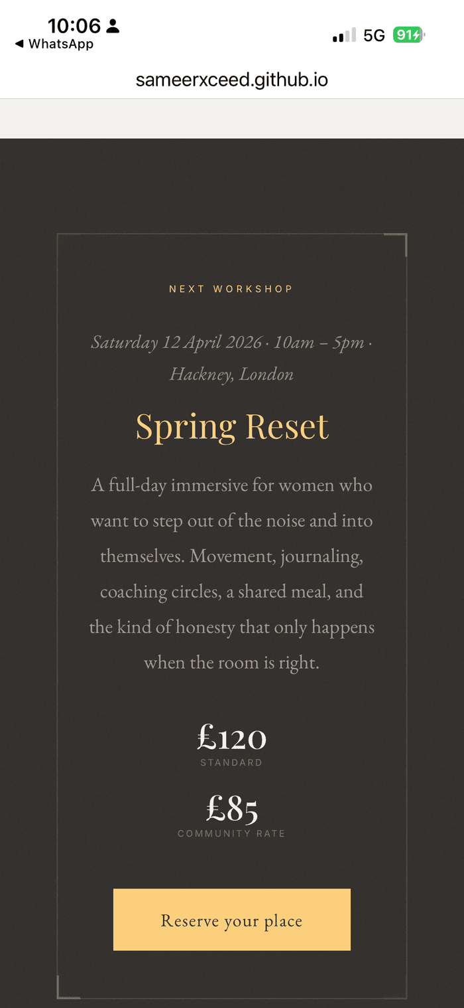
FIX Magazine V1 — Spring Reset at Hackney. Change to Autumn Reset at Taggs Island, Hampton.

Workshop pricing — 200 pound full, 15 pound summary
Agreed pricing is 200 pound full, 15 pound summary. The 120 pound standard and 85 pound community rate shown on some Magazine mockups is wrong.

FIX Magazine V1 — shows 120 pound standard and 85 pound community rate. Wrong. Replace with 200 pound full and 15 pound summary.

Em dashes and en dashes
House style has no dashes in written copy. Currently present in at least seven places across the homepage: hero body, featured article title, Coaching descriptions, Shop description, Reset Stories article title, Reset Letters body, Corporate title. Do a site-wide sweep. Replace with full stops, commas, or rephrase.

Clinical SEO language in body copy
The two-layer system is not being respected. Clinical terms such as somatic coaching, nervous system, TRE, Flash EMDR, Brainspotting, IFS, and Corporate Nervous System Wellbeing belong only in page titles, meta descriptions, and alt text. Visible body copy uses brand language: inner world, inner guidance system, signal system, signal scrambled, signal back online.

FIX First Final Version — clinical SEO copy in visible body (somatic coaching, nervous system, TRE, Breathwork, Flash EMDR, Brainspotting, IFS). Replace with brand language from Volume 3.

Audience framing in the Coaching block and hero
The copy currently leads with life transition, career shift, 'for women who want to stop performing'. This is the wrong way round. The woman is defined by her inner life, not by a category or a problem. Rewrite so the opening speaks to who she is. Life transition language may follow, but must never lead.

FIX Magazine V2 — 'A space for women who are ready to stop performing wellness'. Wrong framing. Rewrite to lead with inner life.

Fictional content throughout
The Featured Reset Story about Lauren is fictional. 'When the Woman You Built Stops Working' is invented. 'Learning to Sit with the Empty Chair' is invented. The line about having the house, the husband, the business, the body is invented. Replace every one of these with real content from Volume 3.
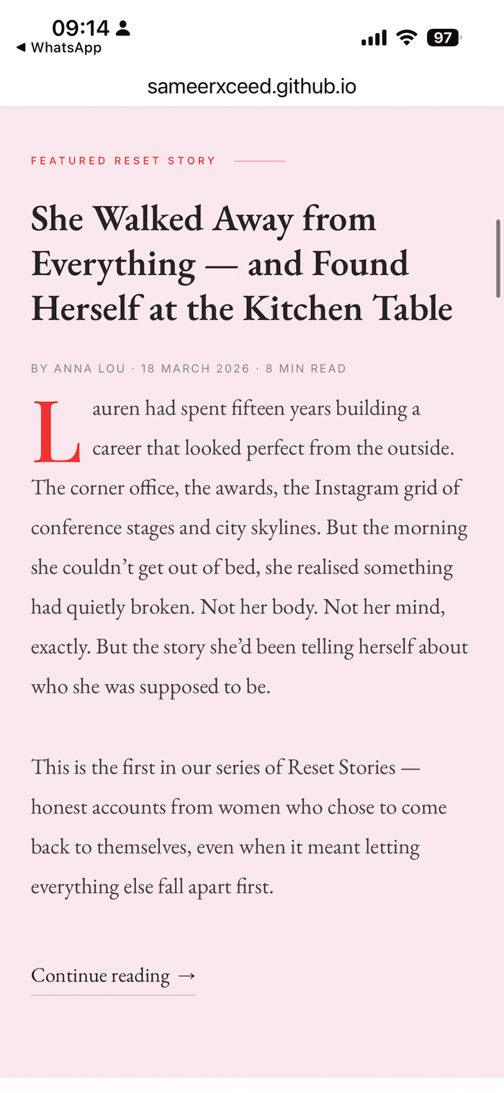
FIX Magazine V2 — fictional Featured Reset Story about 'Lauren'. Replace with a real story from Volume 3.

My Body Kept the Score as an article title
This is the title of Bessel van der Kolk's well-known book. Do not use this phrase anywhere on the site, even partially. Rename completely.
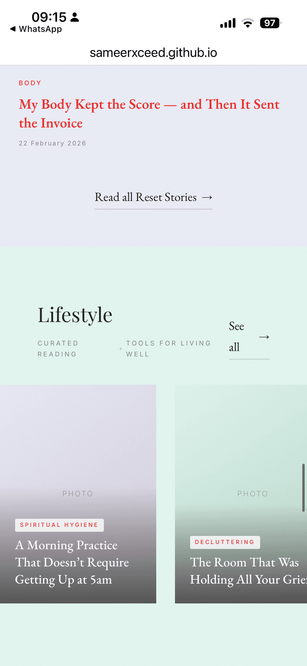
FIX Magazine V2 — 'My Body Kept the Score — and Then It Sent the Invoice' as article title. Bessel van der Kolk book title. Rename completely.

Crown 'a' monogram on Reset Letters
The decorative diamond-a-diamond element and the small a monogram at the bottom of the Reset Letters card both need removing. The crown monogram is not used on the web. Replace with a simple rule, an asterism, or a Garamond ampersand.
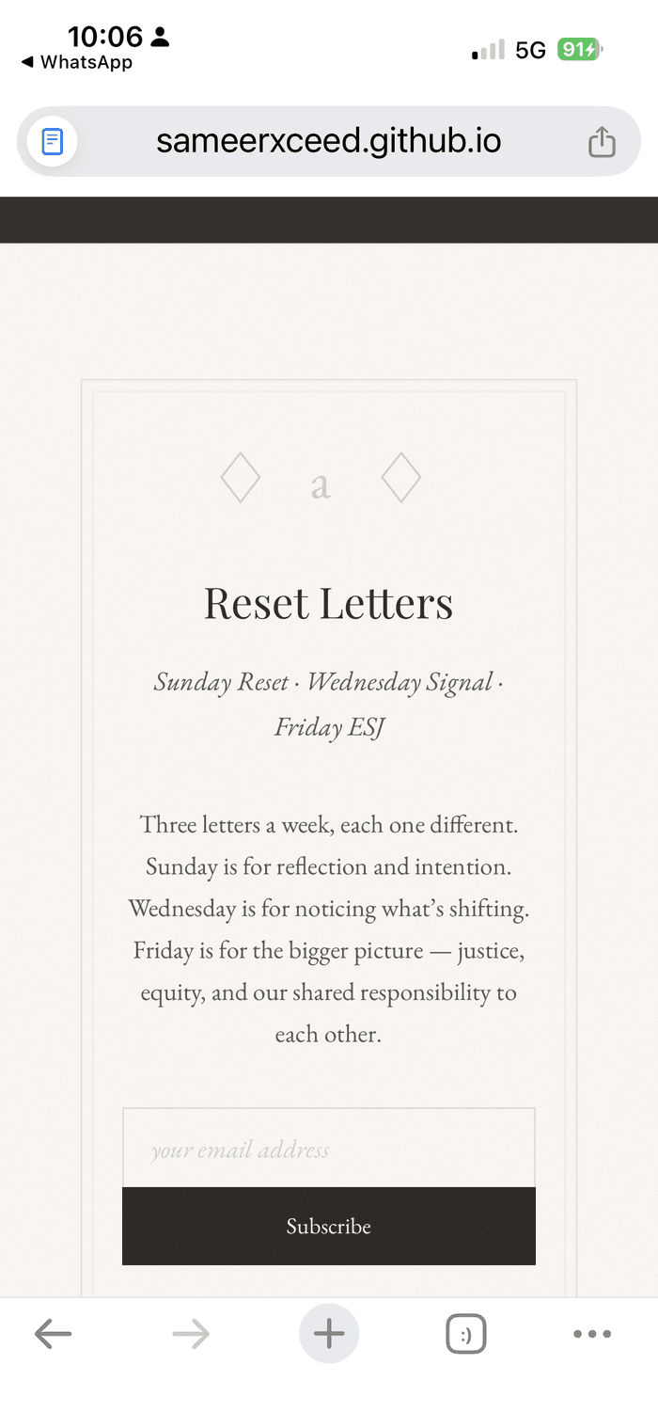
FIX Magazine V1 — decorative diamond-a-diamond element on Reset Letters. Remove.

Two-tier Substack structure
Reset Letters is a two-tier product. Free tier and paid tier. The current single-tier subscribe form contradicts this. Either rewrite per Volume 3 copy to show both tiers clearly, or switch to the proper Substack embed which handles tiering natively. This is the preferred solution.

Friday ESJ framing — strip entirely
The social justice, justice, equity, and shared responsibility language currently on the Reset Letters section is not Anna's and does not appear anywhere in Volume 1, Volume 2, or Volume 3. Strip it entirely. Replace with the actual Volume 3 Reset Letters structure: Sunday Reset Story (personal narrative and inner world reflection), Wednesday Signal Check (nervous system practice explained simply), Friday ESJ Drop (Emotional Support Jewellery story and product link). This copy is canonical. Do not deviate from it.
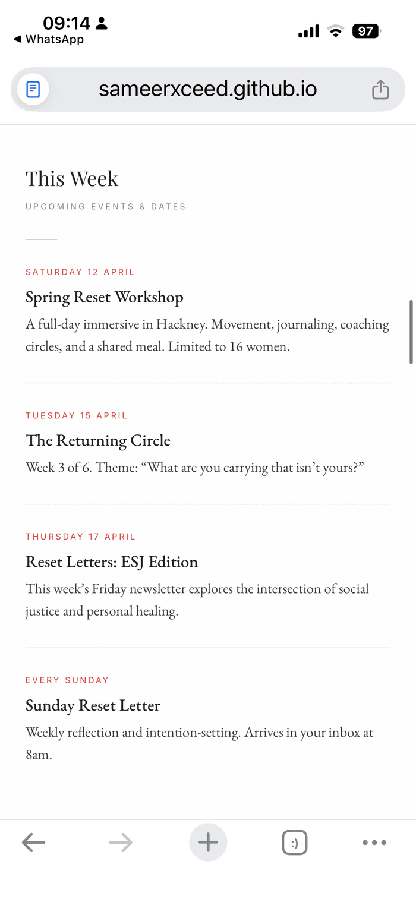  FIX Magazine V2 events board — 'Reset Letters: ESJ Edition. This week's Friday newsletter explores the intersection of social justice and personal healing.' Not Anna's copy. Strip. |   FIX Magazine V1 Reset Letters — 'Friday is for the bigger picture — justice, equity, and our shared responsibility to each other.' Not Anna's copy. Strip.

Press logos and certifications — real artwork, not typed text
Harrods, Selfridges, Harvey Nichols, QVC Japan, The Telegraph, Stylist, and SheerLuxe are currently typed in Garamond italic. Replace all of them with actual licensed logo artwork. Same for ICF Accredited, CPD Certified, TRE Provider, and Trauma-Informed. Replace with proper certification badges where permitted, not text in outlined boxes.
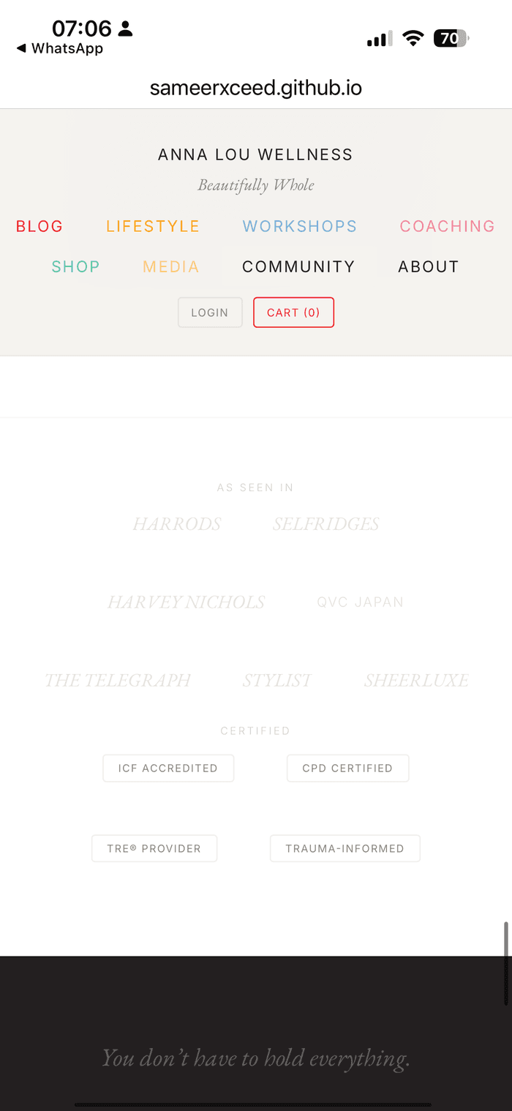
FIX First Final Version — press logos and certifications typed in Garamond italic. Replace with licensed logo artwork and certification badges.

Top-strip wording
Change HOLISTIC COACHING, LIFESTYLE, COMMUNITY to just COACHING, LIFESTYLE, COMMUNITY. Drop the word 'holistic'.

FIX Magazine V2 — top strip reads 'HOLISTIC COACHING · LIFESTYLE · COMMUNITY'. Change to 'COACHING · LIFESTYLE · COMMUNITY'.

5. Confirmations, now resolved
Answers from Anna on every question raised across the feedback rounds. All of these are locked.
- Workshop venue. Taggs Island, Hampton. Sameer, replace Hackney on the workshop card.
- Seasonal framing. Rename Spring Reset to Autumn Reset on the card, since the site launches into September retreat promotion.
- Workshop pricing. 200 pound full, 15 pound summary. Use throughout.
- The Returning Circle venue and audience. The Hare and the Moon, Twickenham. It is not women-only. Change any copy that describes it as a women's circle to inclusive language such as a weekly circle, or a weekly gathering.
- Top-strip wording. Drops 'holistic'. Reads COACHING, LIFESTYLE, COMMUNITY.
- Reset Letters Issue 37 quote. The quote and attribution stand. No change.
- The Signal Method. Reinstated as the umbrella method and brand concept. It sits across the coaching work with the named programmes as the saleable routes in. Keep in coaching copy, on the Autumn Reset Day card, and in SEO metadata.
- Friday ESJ framing. The social justice, justice, equity, and shared responsibility language is not Anna's and does not appear anywhere in Volume 1, Volume 2, or Volume 3. Strip it. Replace with the actual Volume 3 Reset Letters structure: Sunday Reset Story, Wednesday Signal Check, Friday ESJ Drop.

6. What is working. Keep.
- Magazine framing with Issue No. 01 Spring 2026 and Inside this issue. Keep.
- Beautifully Whole tagline in red Garamond italic. Perfect brand rendering. Keep.
- Hero headline Come back to yourself with yourself in red italic. Beautiful. Keep.
- Drop cap L in red on Featured Reset Story. Classic editorial. Keep.
- Red small-cap category labels FEATURED, IDENTITY, GRIEF, BODY and date markers. Clean. Keep.
- Full-bleed red quote slide from V2. Striking. Use throughout, not only once.
- Dark luxe workshop card with gold Garamond from v4. Premium. Keep.
- Card grid structure for articles. Image, category, title, date. Keep.
- Strikethrough pricing on bundles. Tidy. Keep.
- Portrait of Anna section added in V2. Good editorial addition. Keep. Anna will supply a real portrait.
- BOUNDARIES category added in V2. Good editorial tag. Keep.
- Two hero CTAs from V2. Read the Reset Stories and Work with Anna. Reinstate in the combined build.
- V1's warmer cream and tan neutrals as the underlying palette. Keep.
- Logo treatment as a typed wordmark on one horizontal line with Garamond italic tagline below from the First Final Version. Approved. Keep.
- Colour-coded nav system from the First Final Version. Reinstate across all pages.

7. Pre-sign-off checklist
Do not send another iteration until every item below is closed.
- Colour-coded nav reinstated per the First Final Version
- All seven section colours applied correctly with no cross-section leaks
- Programme names on Coaching rebuilt using the agreed seven-name system, sitting underneath The Signal Method as the umbrella
- The Signal Method retained in coaching copy, on the Autumn Reset Day card, and in SEO metadata
- Trauma-Informed Sessions removed as a saleable product
- The Returning Circle moved from Coaching into Community, and all women-only language replaced with inclusive wording
- Workshop venue changed from Hackney to Taggs Island, Hampton throughout
- Spring Reset renamed to Autumn Reset on the workshop card
- Workshop pricing set to 200 pound full, 15 pound summary throughout
- Top strip reads COACHING, LIFESTYLE, COMMUNITY
- Every em dash and en dash removed from written copy
- Clinical SEO copy removed from visible body, brand language inserted from Volume 3
- Audience framing on Coaching and hero rewritten to lead with inner life, not life transition
- Every fictional article, client name, and quote replaced with real Volume 3 content
- My Body Kept the Score as an article title renamed completely
- Crown a monogram removed from the Reset Letters section
- Two-tier Substack structure in place, ideally via the proper Substack embed
- Press logos and certification badges replaced with licensed artwork, not typed text
- Typed stacked logo replaced with horizontal wordmark on one line, Garamond italic tagline below
- Hero CTAs reinstated. Read the Reset Stories, and Work with Anna
- Footer social strip added with the correct URLs once Anna sends them
- Full-bleed red quote slide reinstated from V2 and used throughout for key quotes
- Friday ESJ description replaced with the Volume 3 wording: Emotional Support Jewellery story and product link. All social justice and equity language stripped.

Send v5 once every item above is closed. Do not move onto new pages until the homepage is signed off.

Thanks Sameer. This is the final consolidation across every round of feedback, with visual references pulled from your own mockups. Work from this document only from here on. Close every item before the next iteration.
Anna

